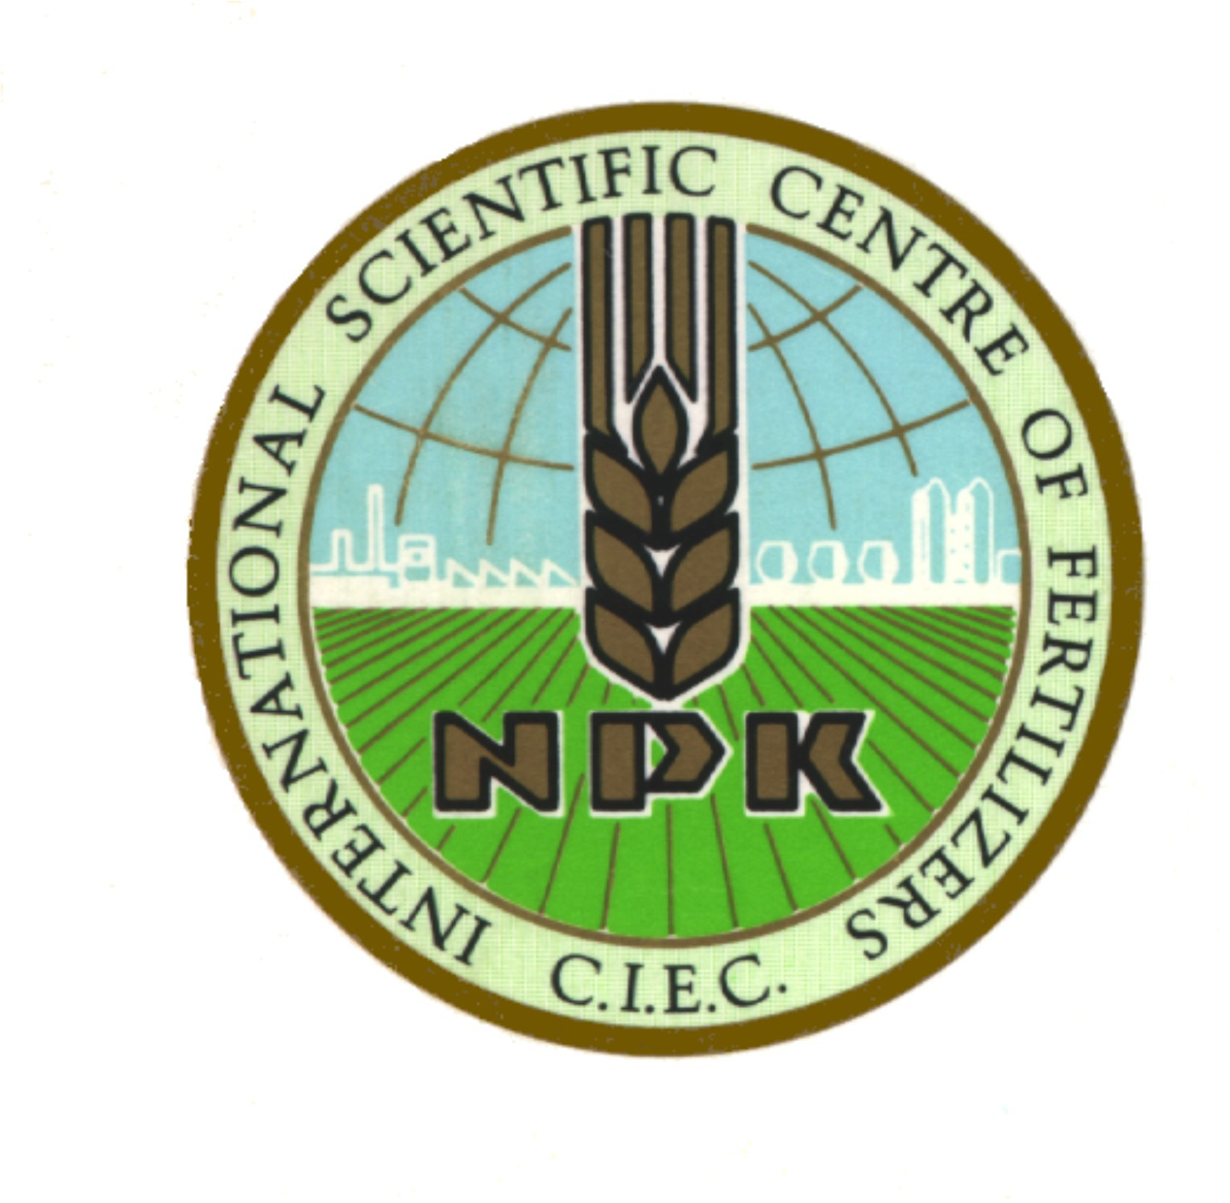

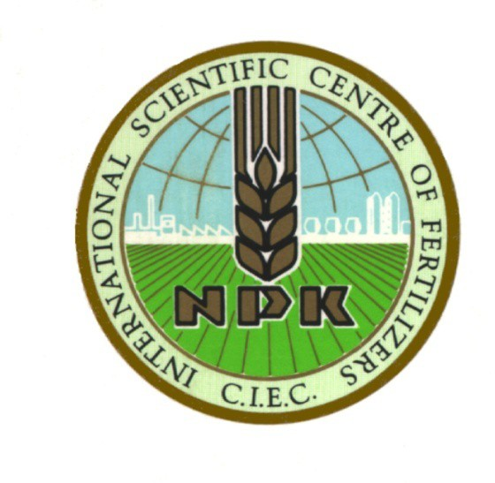Essential CIEC FACTS: founded in 1933,

CIEC (Centre International des Engrais Chimiques)
is the oldest scientific organization solemnly dedicated to fertilization.

CIEC is a non-profit, non-governmental organization (NGO) and actually organized as a task force with membership on invitation only, merged with CIEC-ASIA (founded in 2016) from 2019 on.

The presidium of the CIEC task force consists of the President Lanzhu Ji (PRC), Deputy President Xiaoyu Shi (PRC) + 4 Vice Presidents: Dimitris Bouranis (GR), Luit de Kok (NL), Zhengyi Hu (PRC), Margit Olle (EST), the Secretary General, Silvia Haneklaus (D), the Deputy Secretary
General, Jie Li (PRC), a Liaison Officer for Environment, Liankai Zhang
(PRC), a Liaison Officer for Industry, Yuanliang Shi (PRC) and the
Honorary Presidents Cristian Hera (RO) and Ewald Schnug (D).

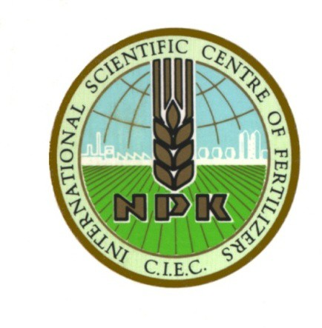

CIEC´s past and present events:

● 17 World Fertilizer Congresses (4 year rotation)

Rome (3), Heidelberg, Opatija, Zurich, Lisbon, Vienna, Moscow, Budapest, Nicosia, Ghent, Beijing, Chiang Mai, Bucharest, Rio de Janeiro, Shenyang, Inner Mongolia (scheduled 2022)
1932-2018: in total est. 12.000 participants)

● 29 Fertilizer Symposia (annually, )

Vienna (2), Benghazi, Brauschweig (3), Balatonfured, Nicosia, Berlin, Salamanca, Kusadasi, Pulawy, Suceava, Tokat, Debrecen, Pretoria, Ghent, Cairo, Rome (2), Goslar, Santa Clara, Bari, Helsinki, Son, Coimbra, Groningen, Guilin, Athens, Cairo, Newcastle upon Tyne (scheduled 2020/21) (1932-2019: in total est. 13.000 participants)

